TASK ON LOAD BALANCER
1.Configure Classic Load balancer.
Creating one classic load balancer
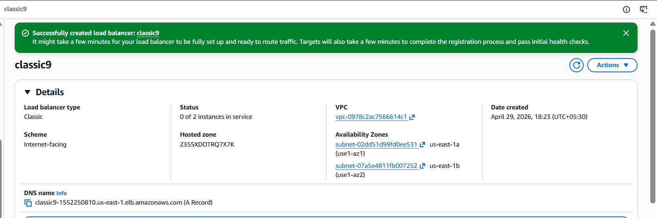
Its works
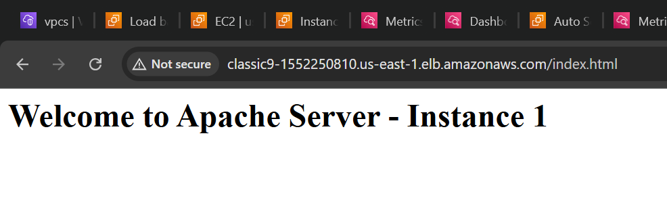
2.Configure Application Load balancer.
Created application load balancer
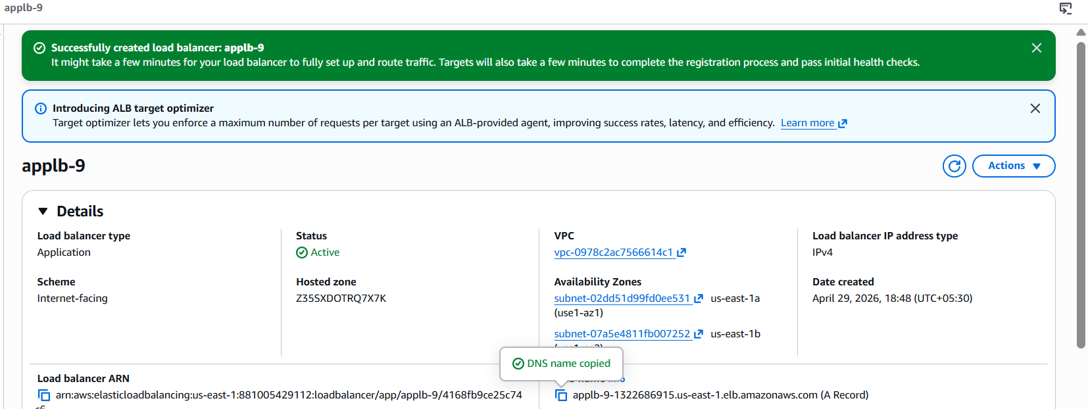
The target group we added to the load balancer
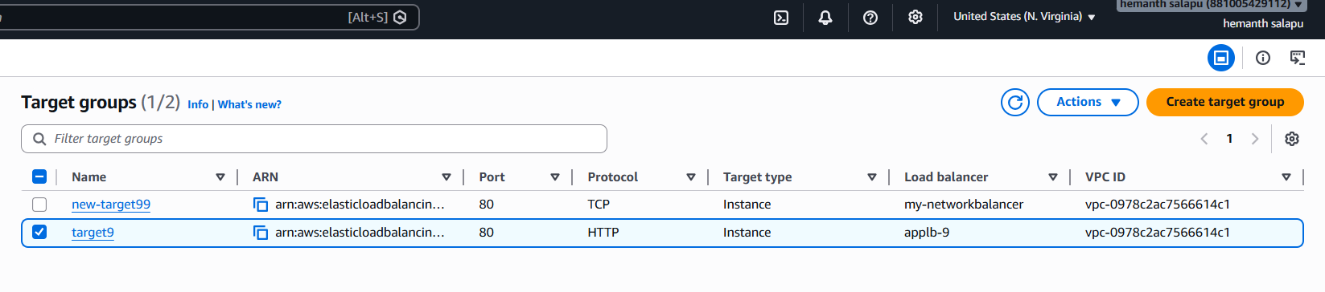
Checking whether the target group is health or not
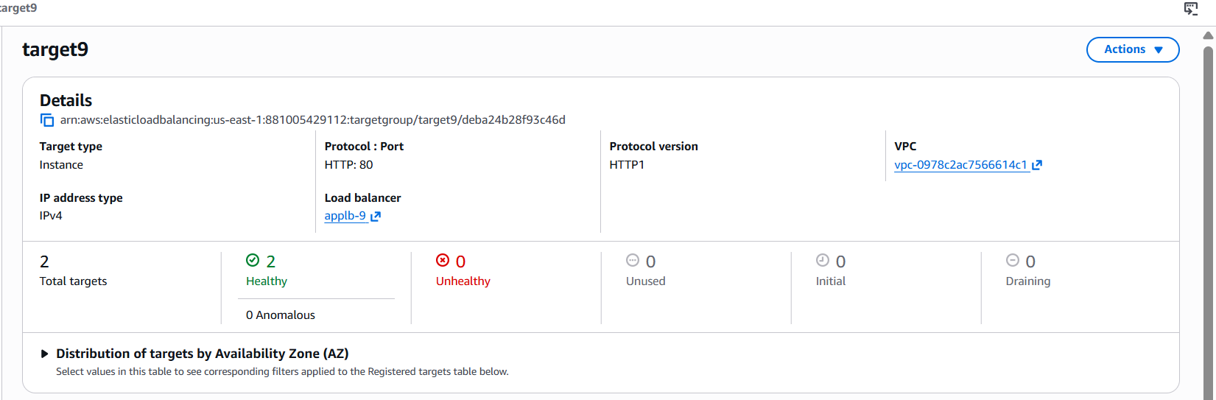
Listeners and rules
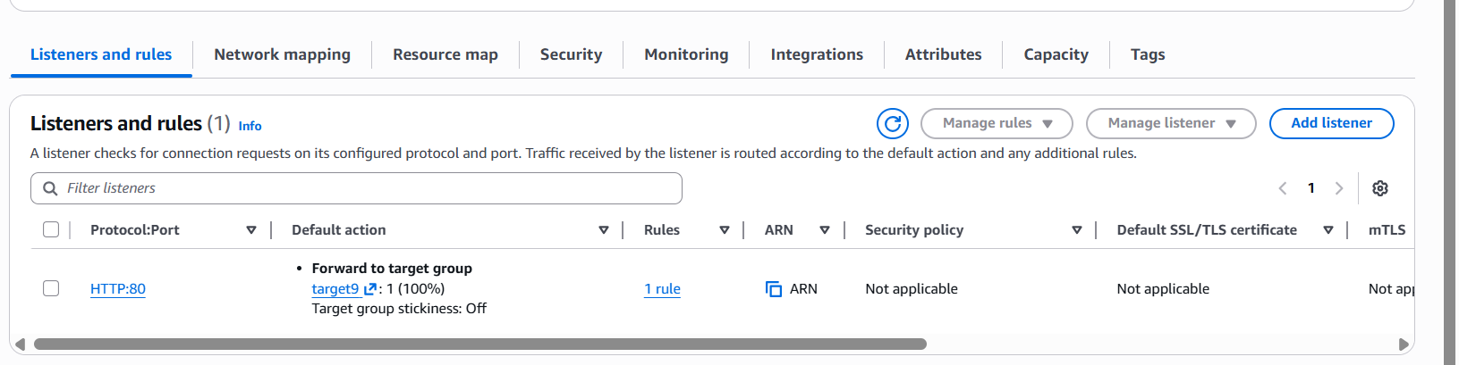
Checking with the application load balancer DNS we can see load is distributed
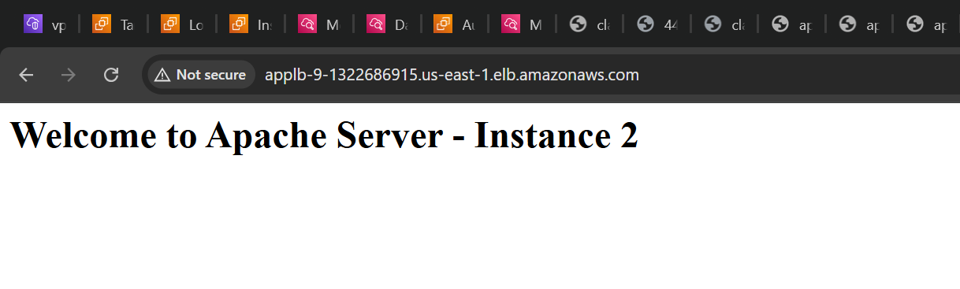
3.Configure Network Load balancer.
Creating network load balancer while creating network load balancer we have to select our VPC and subnets
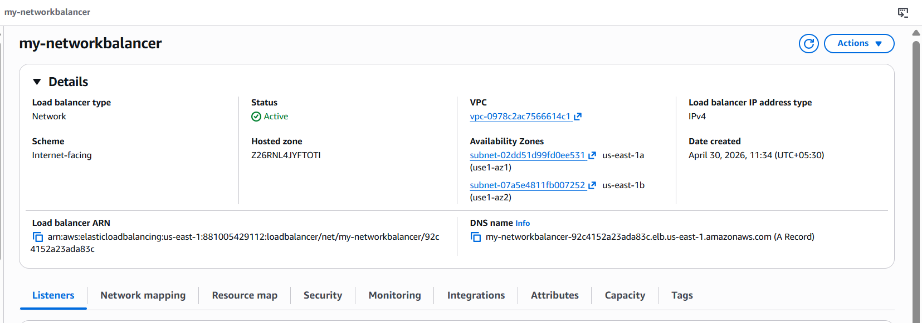
Creating targeting for network load balancer
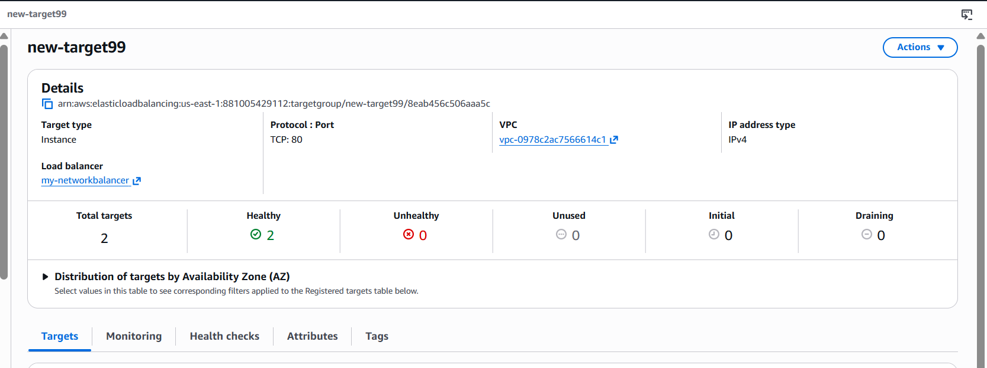
Register your instances
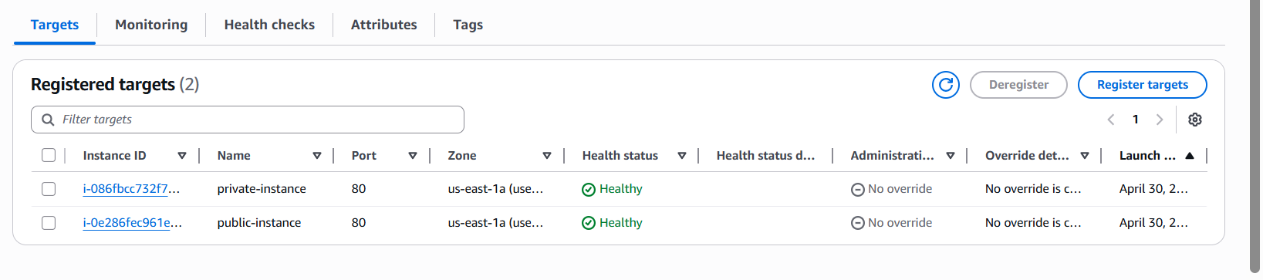
Check with network load balancer DNS
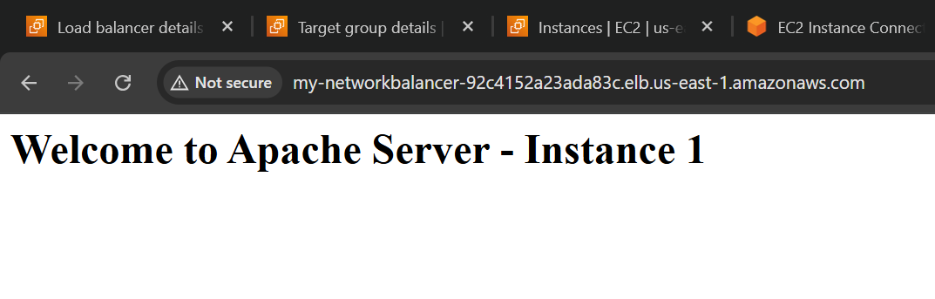
4.Attach SSL for application load balancer.
Go to AWS certificate manger and request sertificate
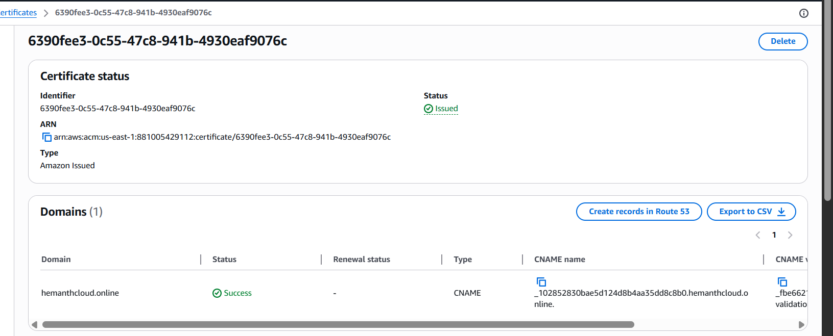
Add HTTPS listener to existing ALB
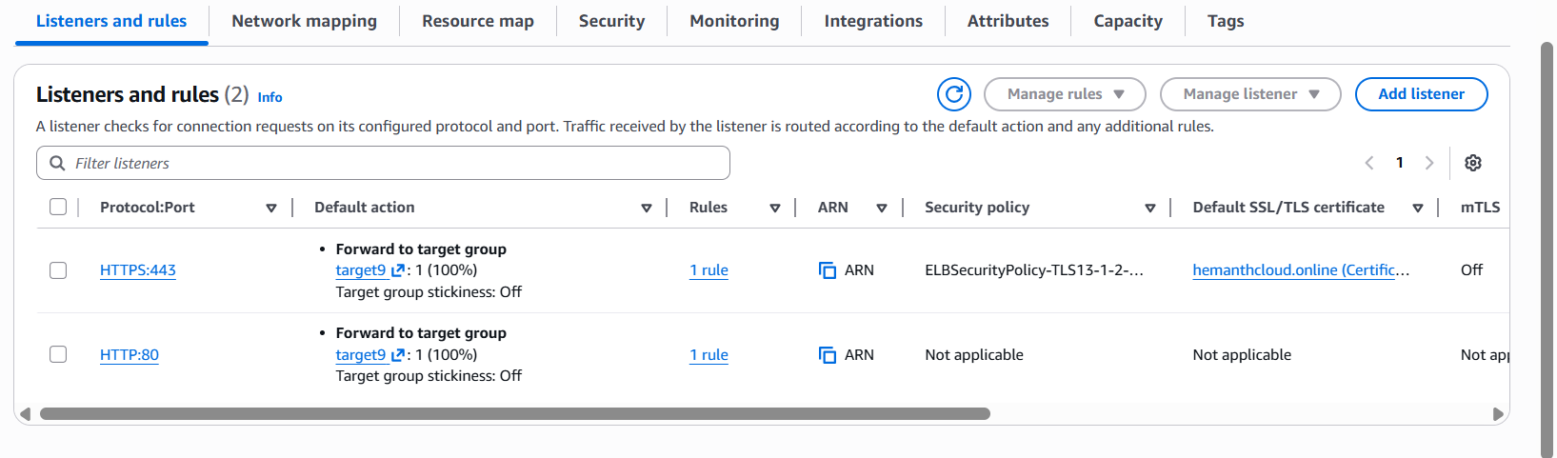
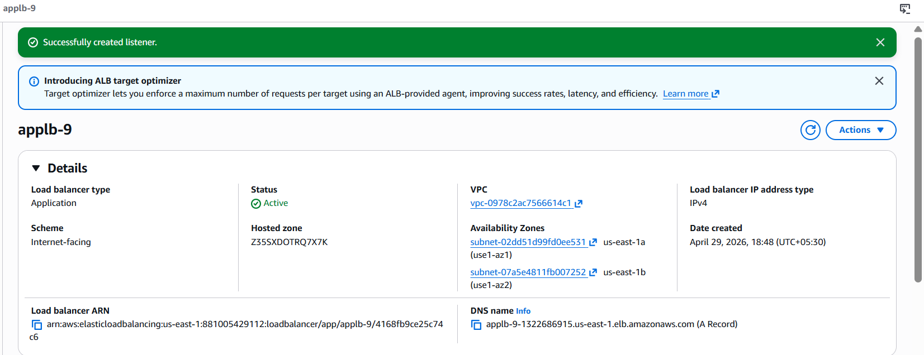

5.Map Application load balancer to R53.
Route 53 to hosted zone to create a record
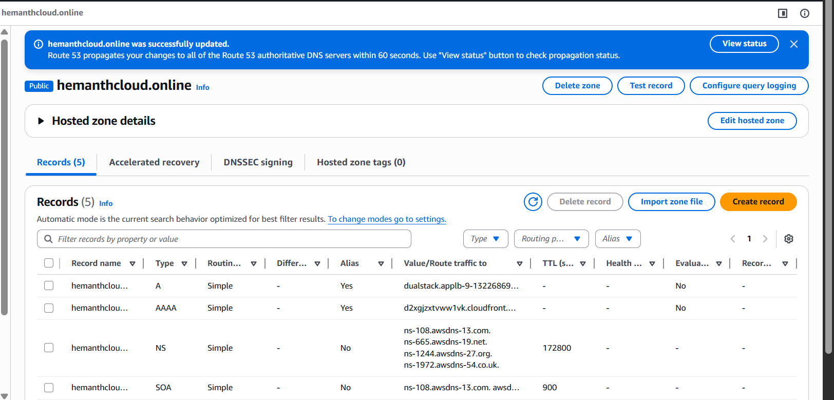
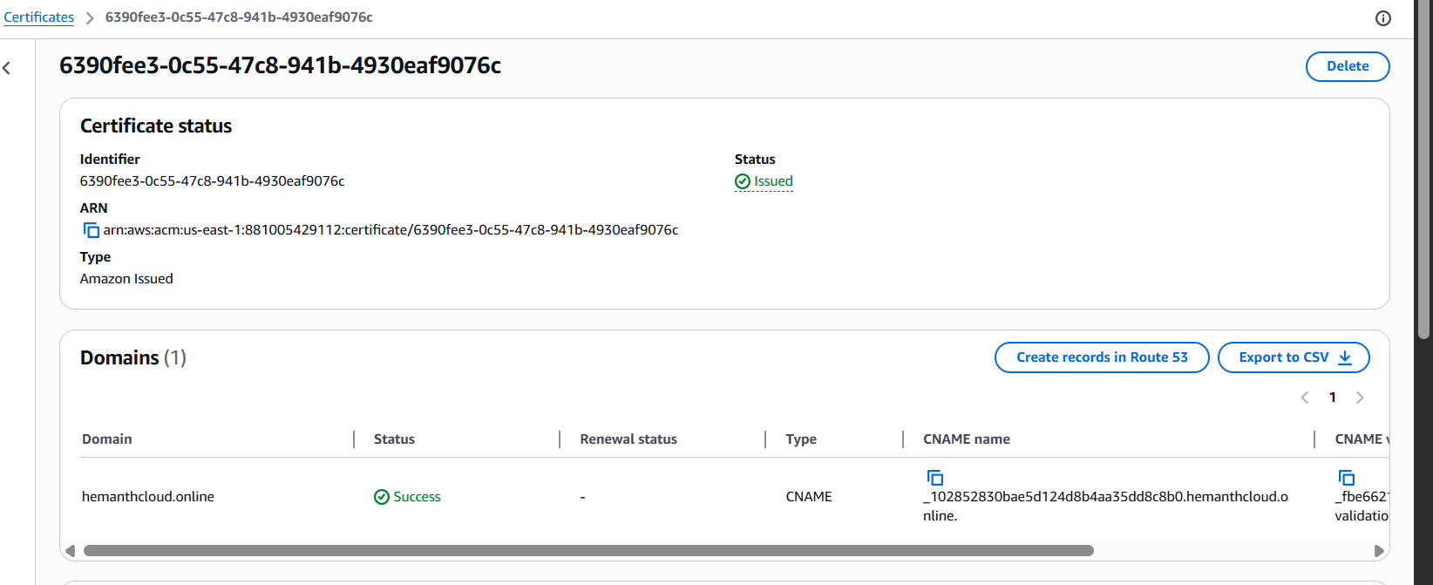
And its works
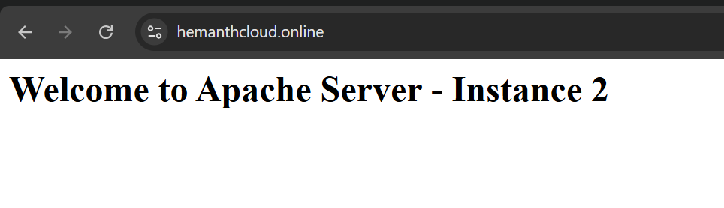
6.Push the application load balancer logs to S3.
Created a bucket
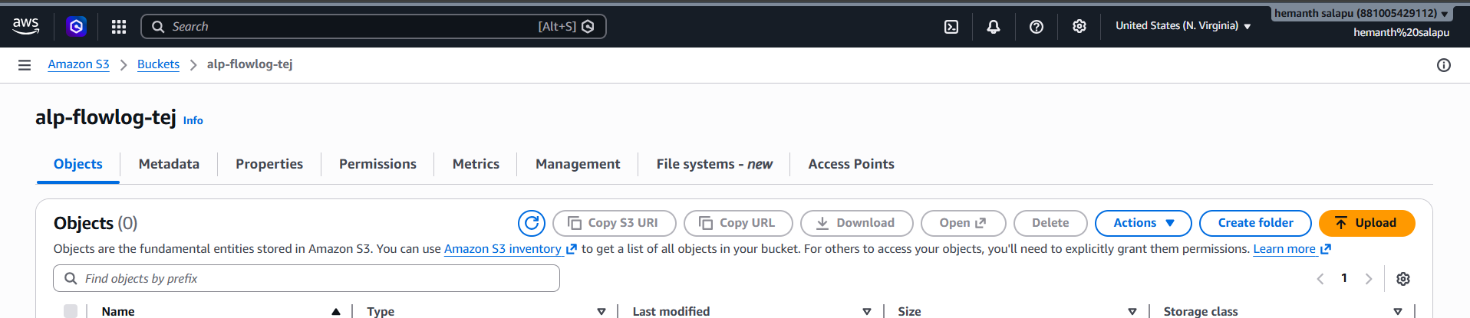
Goto Application load balancer click on Attributes your able to see last→ →
monitoring option click on access logs browse your bucket and selct save→ → →
changes
